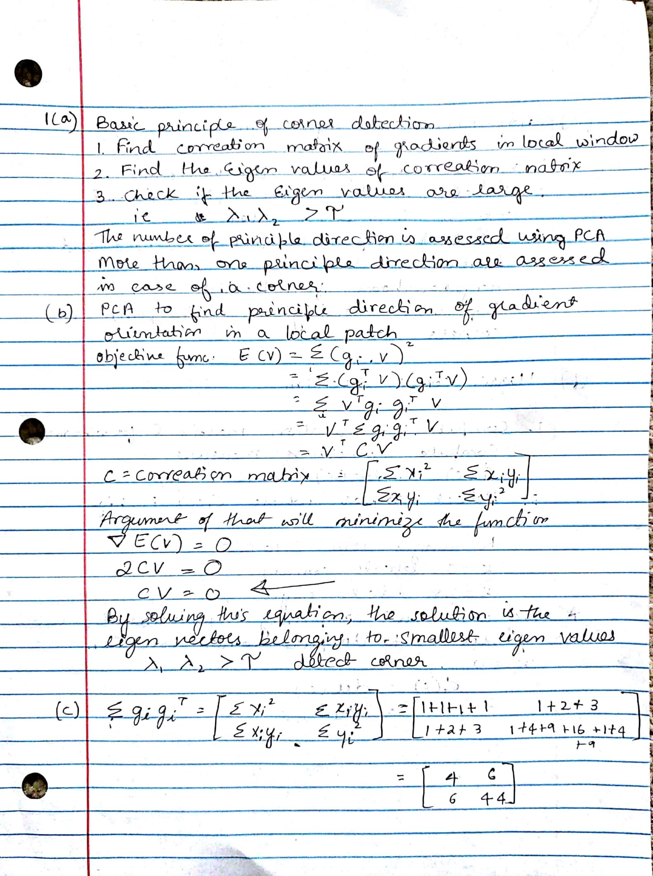

**CS 512 FALL18**

**VISMAYA VEERAMANJU KALYAN**

**A20423189**

